**Enabling Scalable, AI-Driven E-Commerce through Azure & Microservices**

Cloud-native architecture using Azure microservices with built-in AI capabilities to accelerate innovation while optimizing operational costs.

**Before (Legacy Monolith):**

* ⛔ Downtime during peak
* ⛔ Costly, risky releases
* ⛔ Generic customer experience
* ⛔ Reactive decisions

**After (Azure Microservices):**

* ✅ Elastic scale & global uptime
* ✅ Weekly, low-risk deployments
* ✅ AI-powered personalization
* ✅ Real-time data insights

**✅ Strategic Business Impact**

| **Area** | **Business Impact** | **Solution** |
| --- | --- | --- |
| **Scalability & Resilience** | Seamless handling of 3x–5x traffic (sales events, festive spikes) | Auto-scale on demand with **zero downtime** during critical business periods. |
| **Agility & Time-to-Market** | 50–70% faster feature deployment | What used to take **weeks now goes live in days** – enabling real-time campaign rollouts. |
| **Customer Experience** | Personalized journeys, **24x7 AI support** | Better experience = more conversions. Happy customers don’t churn. |
| **Cost Optimization** | **Reduced infra,** support & manual ops costs | Move from **CapEx-heavy to OpEx**. Pay for what you use. AI deflects 40%+ support load. |
| **Security & Compliance** | Integrated identity, audit logs, secure vaults | Built-in **Zero Trust and GDPR** alignment with Azure tools. |
| **Innovation Acceleration** | AI/ML-driven features (**chat, recommendations**) | Faster experimentation — **A/B test** new ideas without big rework. |
| **Data-Driven Decisions** | Real-time analytics & dashboards | Track KPIs instantly — not post-mortem. |
| **Global Reach** | Deploy close to your customers worldwide | Azure **regions** enable low latency access anywhere — faster and cheaper. |
| **Ecosystem Integration** | Plug-and-play with SaaS, marketplaces, APIs | Accelerates partnerships and digital channels (e.g., Instagram Store, POS). |
| **Business Continuity** | Resilient infra with backups & failover | Outages hurt brand trust. **Azure zones + HA** = peace of mind. |
| **Team Productivity** | DevOps + automation reduce manual handoffs | **One-click deployments,** faster onboarding, better resource utilization. |
| **Architecture Governance** | CI/CD gates, testing, observability | No more ‘it worked on dev’. Predictable releases, **rollback safety.** |
| **Legacy Risk Elimination** | Reduce tech debt, support load, upgrade risks | **Avoid license** traps, legacy outages, and inflexible architectures. |

**1: Current State – Legacy E-Commerce Pain Points**  
**Business Challenges:**

* Monolithic .NET applications with tightly coupled code
* Downtime during peak traffic (Black Friday, festive sales)
* Manual deployments causing delays and rollbacks
* Difficult to scale horizontally
* Limited integration with mobile/social/marketplaces
* No real-time personalization or analytics

**Impact:** High IT costs, slower innovation, poor user experience, revenue loss during spikes

**2: Why Modernize?**  
**Business Goals:**

* Faster feature releases (flash sales, campaigns)
* Automated deployments with rollback safety
* Personalized experience based on user behavior
* Resilience, scalability, and security

**Outcomes:**

* Increased customer satisfaction
* Faster time-to-market
* Reduced downtime and cost
* AI and analytics-driven insights

**3: Modern Architecture Vision**  
**Strategy:** Shift from Monolith to Cloud-Native Microservices on Azure

|  |  |
| --- | --- |
| .NET Core Microservices |  |
| Azure API Management (APIM) |  |
| Azure AD B2C for identity |  |
| Azure Cosmos DB + Redis | A diagram of a cloud  AI-generated content may be incorrect.  enter image description here |
| Azure Key Vault + Azure Monitor |  |
| Azure DevOps for CI/CD |  |

**4: Business-Aligned Architecture Highlights**  
**Focus Areas:**

* Event-Driven Architecture for loose coupling

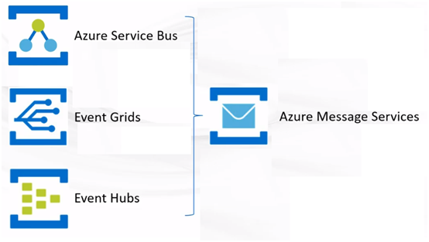

Example:

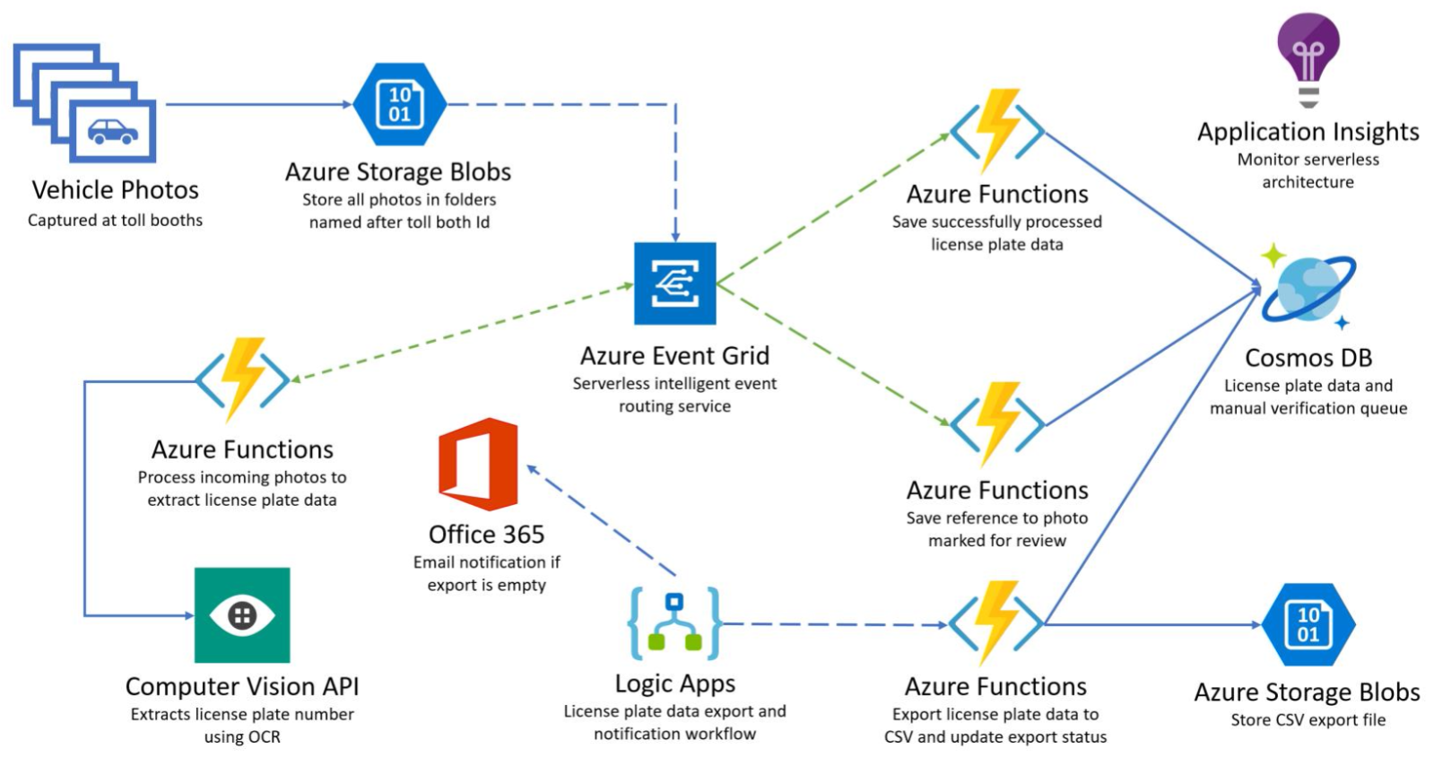

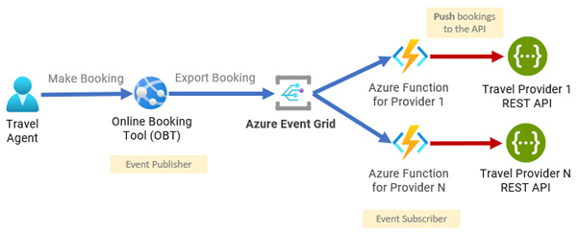

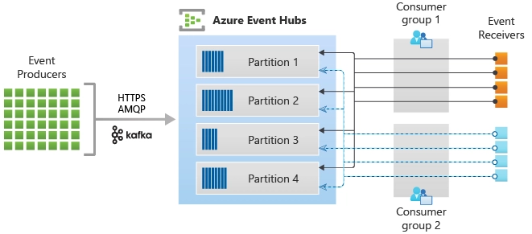

* Microservices by Domain (Product, Cart, Order, Payment)
* Personalization & Chatbot (AI integration)
* Secure DevSecOps pipelines
* Observability through App Insights & Monitor

**5: Transition Roadmap**

|  |  |
| --- | --- |
| **Phase** | **Action** |
| Phase 1 | Assess & Rehost APIs on Azure App Services |
| Phase 2 | Rearchitect into .NET Core Microservices |
| Phase 3 | Add AI Chatbot + Recommendation Engine |
| Phase 4 | Enable global scale & monitoring |

**6: Microservices Patterns & Event-Driven Architecture**  
**Patterns Used:**

* Strangler Pattern – Gradual migration from monolith
* API Gateway Pattern – Centralized access control (via APIM)
* Saga Pattern – Orchestrate long-running transactions
* Outbox Pattern – Reliable event publishing
* Circuit Breaker – Handle downstream failures

**Event-Driven Architecture:**

* Azure Event Grid + Azure Functions for async workflows
* Examples: Order Placed → Inventory Update → Email Notification
* Decouples services for scale, resilience, replayability

**7: AI Chatbot & Personalized Recommendation**

**AI Chatbot:**

* Built using Azure Bot Framework + Azure OpenAI
* Integrates with Azure Cognitive Search for product/FAQ queries
* Azure Functions connect to backend systems for order, return, support
* Cosmos DB tracks session/user context

**Benefits:**

* 24x7 customer support
* 40% reduction in support cost
* Higher CSAT, multilingual & mobile-friendly

**Personalized Recommendations:**

* Azure Synapse + Databricks for data prep
* Azure ML model to predict user-product affinity
* Scoring engine served via Azure Functions + Redis Cache
* Injected into Product APIs and emails in real time

**Business Value:**

* Increased conversion rate and AOV (avg. order value)
* Enhanced customer loyalty through personalization

**8: Strategic Business Impact Summary**

|  |  |
| --- | --- |
| Area | Business Impact |
| Scalability | Handle 3x traffic during sales, global reach |
| Agility | Release new features in days, not weeks |
| Customer Experience | Personalized journeys, AI chat support |
| Cost Optimization | Serverless & AI reduce infra & support costs |
| Security & Compliance | AAD B2C, RBAC, Key Vault, audit logs |

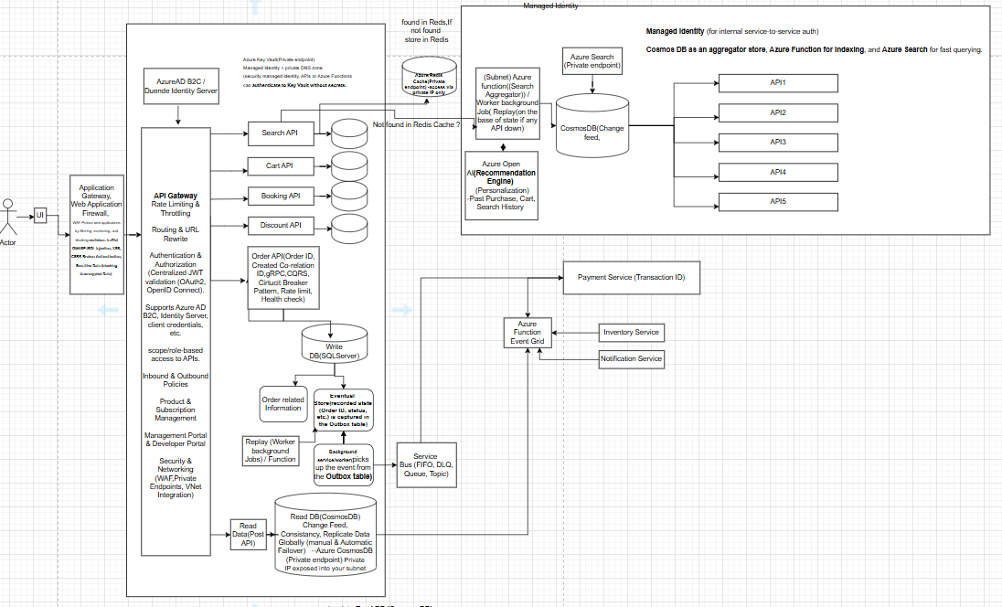





**Microservices (Security, Logging, Monitoring, Communication, Transaction, API Communications)**

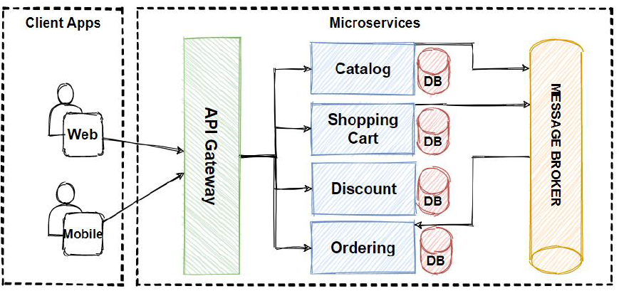

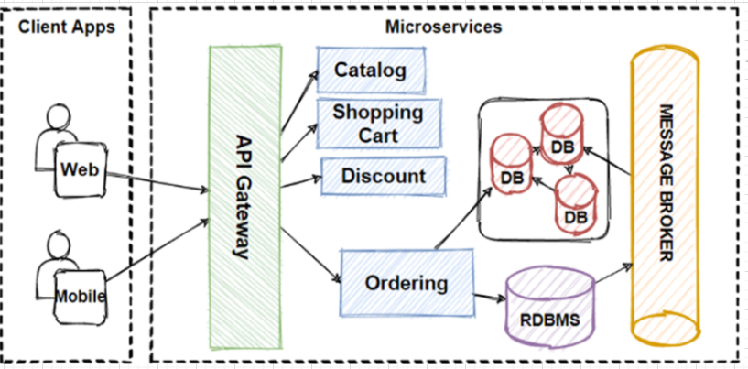

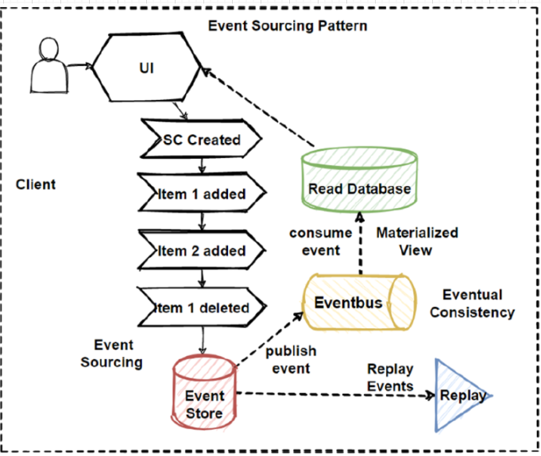

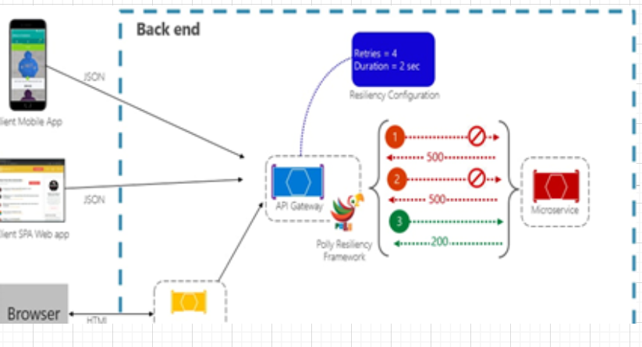

**Azure Landing Zone & WAF (Reliability, Security, Cost, Performance, Operation)**

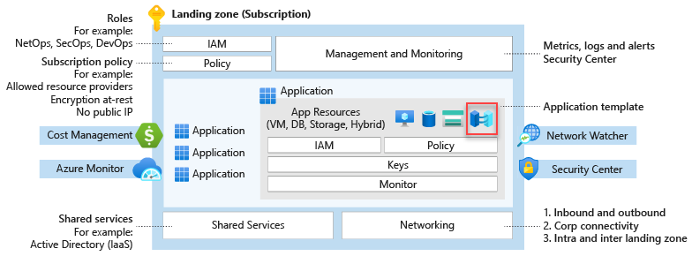

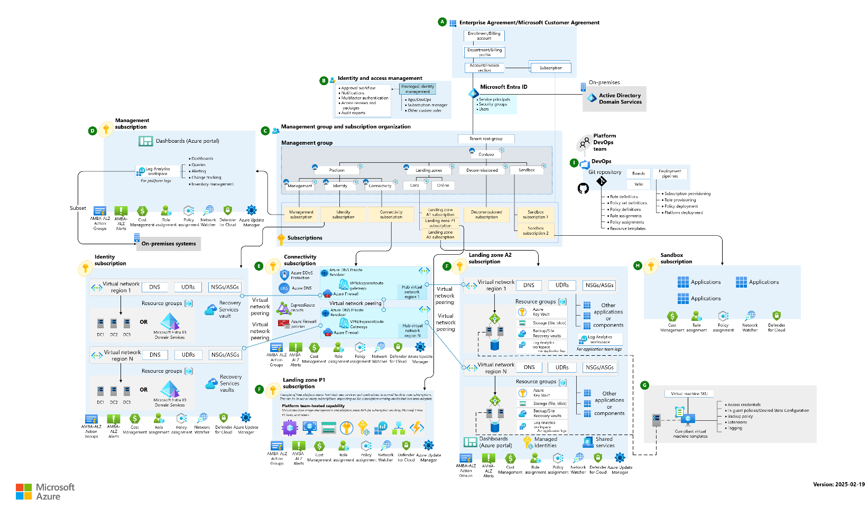

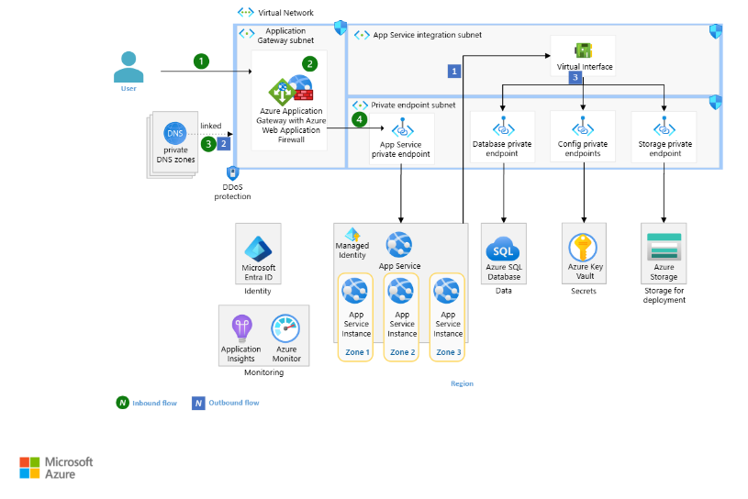

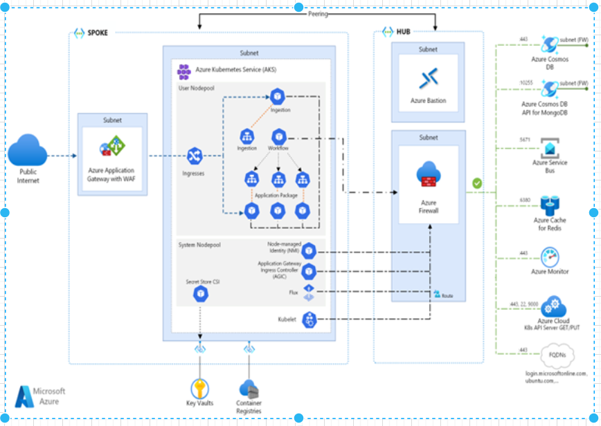

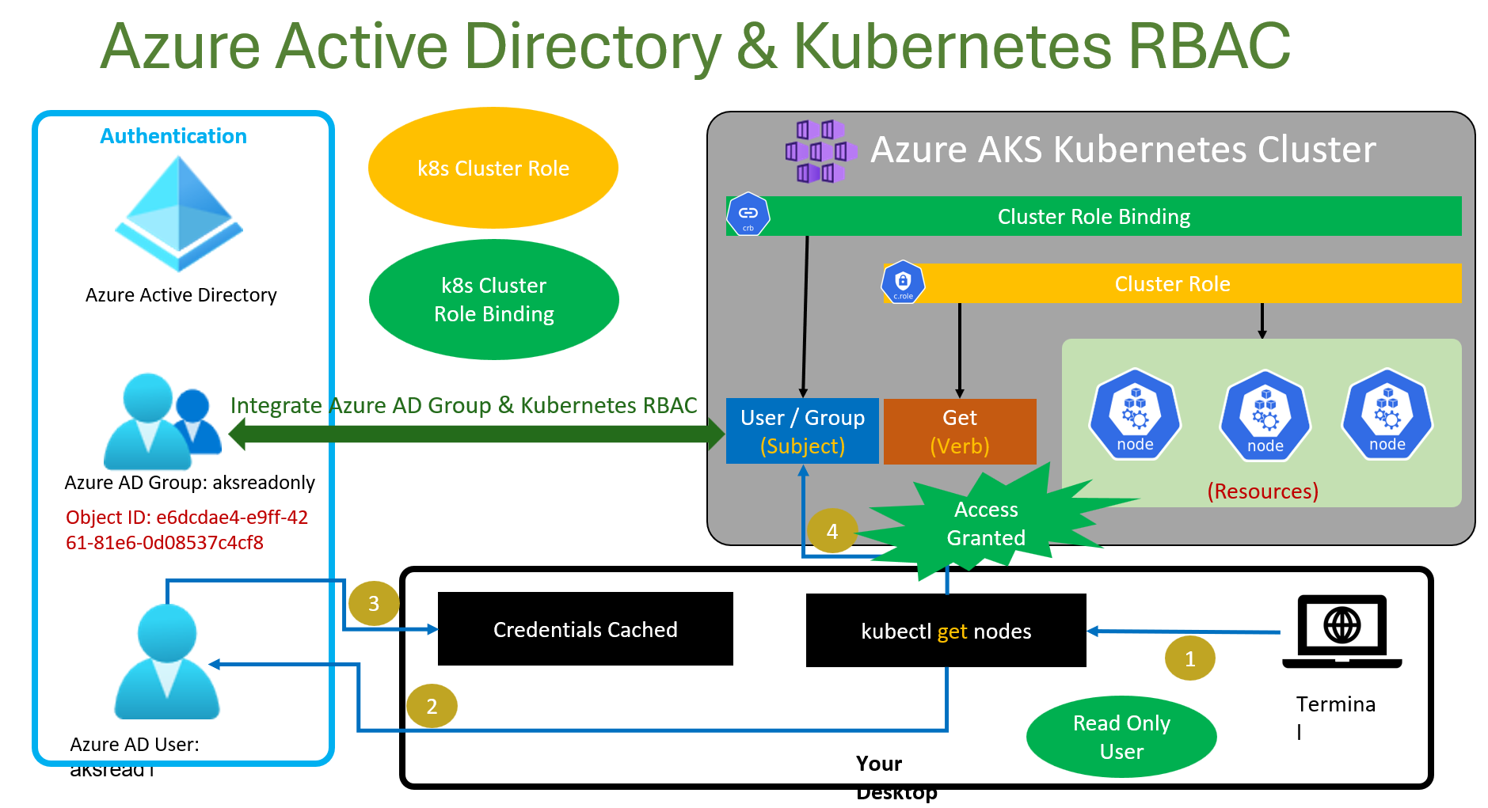

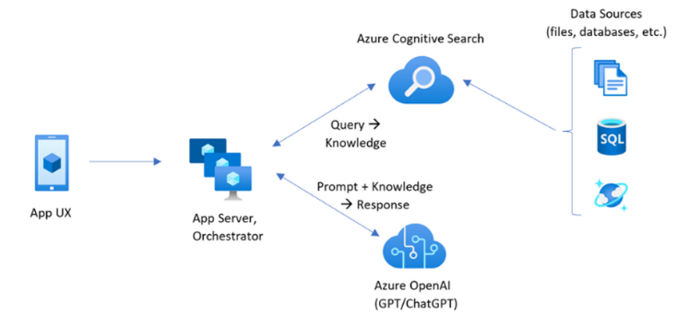

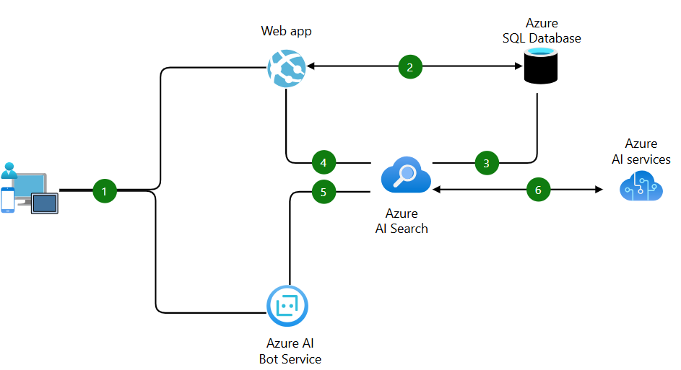







**1. 🛒 Product Table**

| **Column** | **Type** | **Notes** |
| --- | --- | --- |
| ProductId | INT (PK) | Unique product ID |
| Name | VARCHAR(100) | Product name |
| Price | DECIMAL(10,2) | Unit price |
| Quantity | INT | Stock quantity |
| CreatedAt | DATETIME |  |
| UpdatedAt | DATETIME |  |

**2. 📦 Order Table**

| **Column** | **Type** | **Notes** |
| --- | --- | --- |
| OrderId | INT (PK) | Unique order ID |
| UserId | INT (FK) | Reference to customer/user table |
| TotalAmount | DECIMAL(10,2) | Computed sum of items |
| Status | VARCHAR(50) | (e.g., Pending, Paid, Cancelled) |
| CorrelationId | UNIQUEIDENTIFIER | For tracing in distributed systems |
| CreatedAt | DATETIME |  |
| UpdatedAt | DATETIME |  |

**3. 📦 OrderItems Table (many-to-many between Order & Product)**

| **Column** | **Type** | **Notes** |
| --- | --- | --- |
| OrderItemId | INT (PK) |  |
| OrderId | INT (FK) |  |
| ProductId | INT (FK) |  |
| Quantity | INT |  |
| Price | DECIMAL(10,2) | Snapshot price at time of order |

**4. 💸 Payment Table**

| **Column** | **Type** | **Notes** |
| --- | --- | --- |
| PaymentId | INT (PK) | Unique payment ID |
| OrderId | INT (FK) | Associated order |
| Amount | DECIMAL(10,2) | Paid amount |
| PaymentMode | VARCHAR(50) | (e.g., Card, UPI, Wallet) |
| Status | VARCHAR(50) | (e.g., Initiated, Success, Fail) |
| TransactionId | VARCHAR(100) | Gateway TXN ID |
| CreatedAt | DATETIME |  |

**5. 📤 Outbox Table (for Event-Driven Architecture)**

| **Column** | **Type** | **Notes** |
| --- | --- | --- |
| EventId | INT (PK) | Unique event |
| AggregateType | VARCHAR(50) | e.g., Order, Payment, Product |
| AggregateId | INT | e.g., OrderId, PaymentId |
| EventType | VARCHAR(100) | e.g., OrderCreated, PaymentSuccess |
| EventPayload | NVARCHAR(MAX) | JSON data of the event |
| State | VARCHAR(20) | New, Processed, Failed |
| CreatedAt | DATETIME |  |

| **Concern** | **How** |
| --- | --- |
| 💰 **Cloud is expensive** | It’s more predictable**, auto-scalable, and cost-optimized** when designed right. Also: less infra overhead, fewer manual ops. |
| 🔄 **Why change if it’s working?** | The risk of standing still is greater — speed, personalization, scale, and competition won’t wait. |
| 🤖 **AI sounds complex** | We’ve built plug-and-play solutions using Azure OpenAI and Search, fully integrated with existing support and product systems. |
| 🚨 **What about data and compliance?** | We use Azure AD B2C, RBAC, Key Vault, and Policy with audit-ready logs — aligned with GDPR/PCI/ISO. |

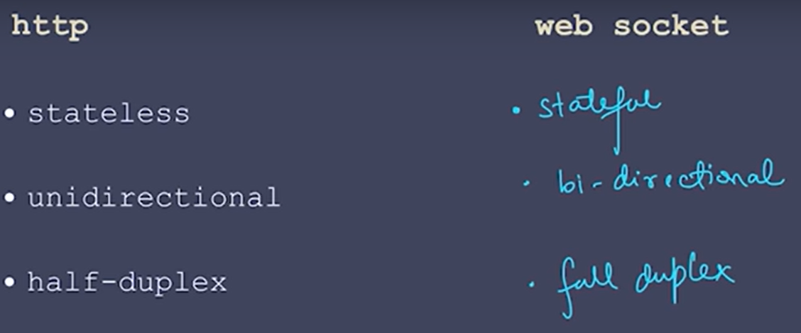

|  |
| --- |
| **Insert or update data in your Cosmos DB, and the worker will pick it up automatically via the Change Feed.**  using Microsoft.Extensions.Hosting;  using Microsoft.Extensions.Logging;  using Microsoft.Extensions.Configuration;  using Microsoft.Azure.Cosmos;  using System;  using System.Threading;  using System.Threading.Tasks;  public class Worker : BackgroundService  {  private readonly ILogger<Worker> _logger;  private readonly IConfiguration _config;  private CosmosClient _cosmosClient;  private Container _container;  private Container _leaseContainer;  public Worker(ILogger<Worker> logger, IConfiguration config)  {  _logger = logger;  _config = config;  }  public override async Task StartAsync(CancellationToken cancellationToken)  {  var connectionString = _config["CosmosDb:ConnectionString"];  var databaseName = _config["CosmosDb:DatabaseName"];  var containerName = _config["CosmosDb:ContainerName"];  var leaseContainerName = _config["CosmosDb:LeaseContainerName"];  _cosmosClient = new CosmosClient(connectionString);  _container = _cosmosClient.GetContainer(databaseName, containerName);  _leaseContainer = _cosmosClient.GetContainer(databaseName, leaseContainerName);  await StartChangeFeedProcessor();  }  private async Task StartChangeFeedProcessor()  {  var processor = _container.GetChangeFeedProcessorBuilder<dynamic>(  processorName: "my-worker-processor",  onChangesDelegate: async (changes, cancellationToken) =>  {  foreach (var item in changes)  {  // Process new or updated document  Console.WriteLine($"Detected change: {item}");  }  })  .WithInstanceName("console-worker")  .WithLeaseContainer(_leaseContainer)  .Build();  await processor.StartAsync();  }  protected override Task ExecuteAsync(CancellationToken stoppingToken) => Task.CompletedTask;  public override async Task StopAsync(CancellationToken cancellationToken)  {  _cosmosClient?.Dispose();  await base.StopAsync(cancellationToken);  }  } |

|  |
| --- |
| <policies>  <inbound>  <base />  **<rewrite-uri template="/v2/US/hardware/{storenumber}&{ordernumber}?City=city&State=state" />**  </inbound>  <outbound>  <base />  </outbound>  </policies> |

|  |
| --- |
| • **User Authentication via Angular Application:**   * The user accesses the **Angular application**.​ * The application redirects the user to **Azure AD B2C** for authentication.​ * Upon successful login, Azure AD B2C issues an **ID token** (containing user information) and an **access token** (for API access).​   • **API Request with Access Token:**   * The Angular application includes the **access token** in the Authorization header of HTTP requests to the APIs.​ * Requests are sent to **Azure API Management (APIM)**, which serves as a gateway to your backend microservices.​   • **Token Validation in APIM:**   * APIM validates the incoming **JWT access token** by checking:​   + **Issuer:** Ensures the token was issued by your Azure AD B2C tenant.   + **Audience:** Confirms the token is intended for your API.   + **Signature and Expiry:** Verifies the token's integrity and validity period. * If validation fails, APIM returns a 401 Unauthorized response.​   • **Forwarding Valid Requests to Backend Microservices:**   * For valid tokens, APIM forwards the request to the appropriate backend microservice hosted on **Azure App Services**.​ * Backend microservices process the request and send responses back through APIM to the Angular application. |
| <inbound>  <validate-jwt header-name="Authorization" failed-validation-httpcode="401" failed-validation-error-message="Unauthorized. Access token is missing or invalid.">  <openid-config url="https://<your-tenant-name>.b2clogin.com/<your-tenant-id>/v2.0/.well-known/openid-configuration" />  <audiences>  <audience**>api://<your-api-client-id></**audience>  </audiences>  <issuers>  <issuer>**https://<your-tenant-name>.b2clogin.com/<your-tenant-id>/v2.0/</issuer>**  </issuers>  </validate-jwt>  <base />  </inbound> |

